
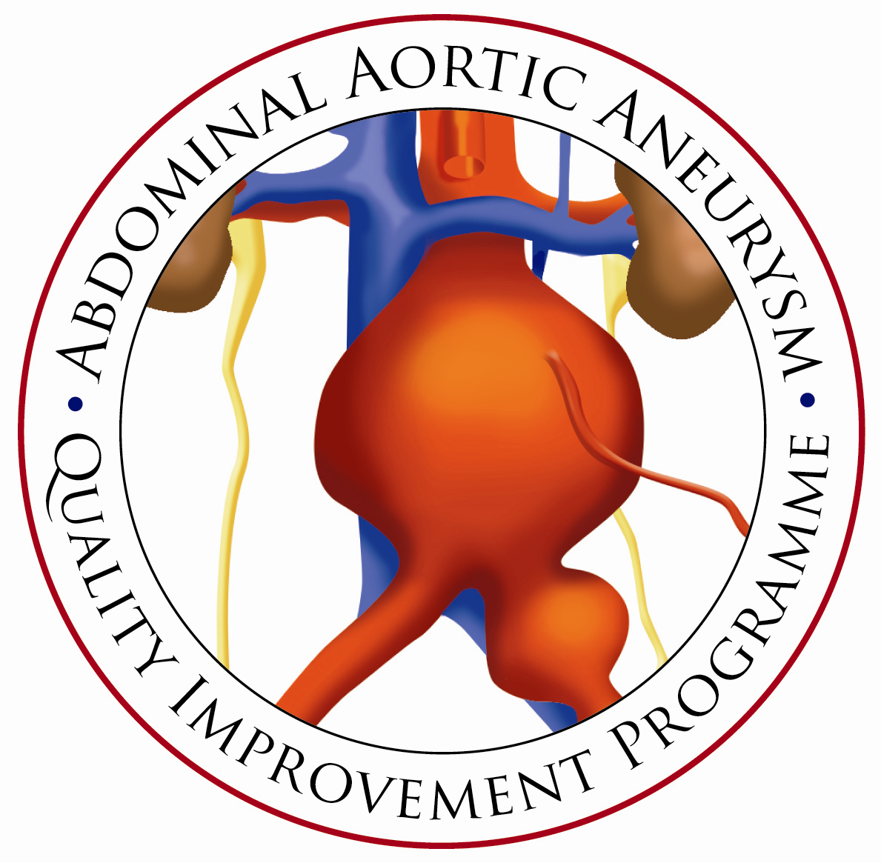
ABDOMINAL AORTIC ANEURYSM QUALITY IMPROVEMENT PROGRAMME

ELECTIVE ABDOMINAL AORTIC ANEURYSM
POST-OPERATIVE COMMUNICATION CARE BUNDLE

Guidance Notes For Use
Introduction

The National AAA Quality Improvement Programme seeks to drive up the standard of care provided to patients with AAA. Vascular clinicians taking part in our regional action plans have consistently revealed that they are ‘unsure about particularly what patients’ get out of information’. Fulfilment of expectations is a strong predictor of patient experience (Pettersen at al, 2004). High quality communication helps to set expectations appropriately so that patients are mentally prepared for their operation.

High quality patient information:
- Enables patients to participate in decisions about their health and health care.
- Clarifies treatment options, highlighting risks and benefits and any areas of uncertainty.
- Encourages patients to take responsibility for maintaining their health.
- Clarifies what the Trust can and cannot provide.
- Reinforces verbal information as part of the process of informed consent.
- Improves patient safety.
- Reduces patient anxiety and improve patient outcomes.
Part of the QIP revolves around ascertaining patient views and seeking their active contribution to the production of written information and delivery of the programme. National patient groups have been set up in 7 regions of the U.K including Bristol, Newcastle, Leeds, Manchester, Aberdeen, Cardiff and London. A consistent theme that has emerged nationally is that patients feel they do not receive enough post operative information, in particular what to expect. Many patients reported that they faced unexpected consequences from AAA surgery and as a result this lead to anxiousness in their recovery. Patients' expectations need to be corrected and hospitals have a responsibility to provide the appropriate information to ensure patients’ experience the best possible care.

Therefore, the AAA QIP has outlined a strategy that aims to:
- Address the lack of post operative recovery information that has been identified nationally.
- Standardise the process of providing patient information.
- Ensure patients are fully informed upon discharge (inc medication, pain relief & follow up).
- Ensure patients are provided with a point of contact post-operatively to address concerns.

The following care bundle has been designed to achieve these aims. It should be implemented on all patients after surgical intervention.

The Care Bundles Concept
The theory behind care bundles is that when several evidence-based interventions/guidelines are grouped together and applied in a single ‘protocol’, it will improve patient outcome^{6.}
It is a simple method of monitoring adherence/existence of local guidelines, and as such is a valid assessment of quality.
- It will provide rapid easily interpretable information.

It is a form of auditing and can identify areas for improvement.

It is NOT prescriptive. Each unit can identify their own criteria for each element.
AAA POST OPERATIVE COMMUNICATION CARE BUNDLE
AAA PATIENTS FOLLOWING SURGICAL INTERVENTION

Protocol in Care Bundle | Intervention | Measure
DISCHARGE:  - Patients should be given a written recovery patient information leaflet. | Provide patient with AAAQIP ‘Recovery from AAA Repair (OPEN and EVAR)’ patient information leaflet.  Available at:  http://www.aaaqip.com/aaaqip/pi-patient-information-leaflets.html | No. of patients receiving AAA recovery leaflet for the type of repair they received.
- Provide patients with a consultation upon discharge to include explanations of any:  - Complications  - Implications for recovery  - Medication  - Follow up. | Consultation with specialist nurse/ ward sister to be included as integral part of AAA discharge procedure. | No. of patients provided with consultation upon discharge.
- Provide patients with a contact number to phone for advice in the early post-operative period. | Ensure local contact information is provided to patient. | No. of patients receiving local contact number.
- Verbal telephone follow up: All patients should be contacted by a named individual (specialist nurse/ house officer) in the early post operative period to check on recovery progress. | Specialist nurse/ named individual to schedule and undertake follow up telephone call. (Proforma 1) | No. of patients receiving follow up telephone call between 48-72 hours/1 week after discharge.

Notes:
- The AAAQIP ‘Recovery from AAA Repair (OPEN & EVAR)’ patient information leaflets have been developed in collaboration with national AAA patient groups. These include information on what to expect on the ward, mobilizing procedures etc… Pain, medication, mobility, driving and work upon returning home and important information about follow up and what to do if problems occur. They also include findings from our patient groups such as feeling low in spirits, the possibility of longer recovery times and post operative symptoms.
Available at: http://www.aaaqip.com/aaaqip/pi-patient-information-leaflets.html
- Findings from our national patient groups have revealed that many patients are not informed about the consequences of complications once they have occurred and patients lack explanations on medication including pain and statins and when to lower dosage. The vascular team should have a consistent approach to communication about progress along the pathway and reinforce agreed discharge plans. Variance should be clearly explained along with implications for discharge from hospital and future recovery.
- Patients should be provided with both a normal working hour’s telephone point of contact as well as an out of hour’s point of contact. This can include a local specialist vascular nurse, GP or emergency department.
- A verbal telephone follow up call should take place between 48 - 72 hours/1 week following discharge. This provides an opportunity to ensure that recovery is proceeding as planned and to answer any queries that patients or their carers may have.
PROFORMA 1

TELEPHONE FOLLOW UP PROTOCOL FOR AAA PATIENTS

This proforma is to be used as a guide for telephone follow ups for AAA patients who have been discharged from hospital. The telephone follow up should take place between 48-72 hours/ 1 week after discharge depending on the locally agreed protocol.

Expected post operative symptoms:
- OPEN REPAIR: Patients will still be sore and having difficulty moving, but should be coping with oral painkillers.
Medication: Pain killers
Follow up appointment: No

- EVAR: Patients should be getting up and about without much pain, controlled on oral analgesia.
Medication: Pain killers
Follow up appointment: Yes (6 weeks)

Patient Name:  Patient I.D: | Type of repair:  OR   EVAR  | Date discharged:
Name of clinician carrying out telephone follow up: | Job role: | Date:
- How are you feeling following your surgery?

If patient is feeling ill: Clarify if it is pain, illness such as upset tummy or chest problems such as a cough.
- Do you have a family member/ carer looking after you?
Yes  No 
If no; suggest the patient seeks help from a family member or friend.
- Were you prescribed pain killers upon discharge?
Yes  No 
If no; send new prescription (ACTION)
- Have you got any pain?
Yes  No 

If yes: Are you managing this adequately with the painkillers provided?
Yes  No 

- Are you clear about the medication you should be taking i.e. statins?
Yes  No 
- Are you clear about what happened during your operation i.e. any complications and how long it should take you to recover?

Yes  No 
If no; inform of any complications that occurred and send recovery leaflet (ACTION)
- Is your wound(s) healing satisfactorily?
Yes  No 
If no, why?

  - Is your wound(s) dry?
Yes  No 

  - Is there any surrounding redness or discharge from the wound(s)?
Yes: redness  No 
discharge 
If yes; Book for early follow up appointment (ACTION)
- Do you have any stitches and clips still in place?
Yes  No 

  - If yes do you have a date for them to be removed by the district nurse?
Yes  No 
If no, Follow this up (ACTION)
- Are you aware of when your next follow up appointment is?
Yes  No 
If no, Check this and let the patient know (ACTION)
- Did you get written information given to you before or after your operation?
Yes  No 
- Did you find it useful?
Yes  No 
  - If no, what else would like to see in it?

- Are there any concerns I can help you with today?
Actions required (please list all and then carry them out)
ACTION |  |  | REQUIRED | COMPLETED
- Resend prescription (pain killer / statin ). |  |  |  | 
- Resend patient information leaflet |  |  |  | 
- Ensure the patient is booked into be seen by the district nurse and inform patient. |  |  |  | 
- Book for early follow up appointment |  |  |  | 
- Book for standard follow up appointment |  |  |  | 
 |  |  |  | 
 |  |  |  | 
 |  |  |  | 
 |  |  |  | 

Please return this form to the relevant consultant’s office for filing in the patient’s notes. (This is a formal record and will be signed off in the patient’s notes).

Consultant sign off
Name: Date:
AAA POST OPERATIVE COMMUNICATION CARE BUNDLE AUDIT TOOL

Has the patient undergone elective AAA repair (OPEN/EVAR)?
Please tick one
OPEN  EVAR 

Insert Label

Patient ID:

Date & Time: ……/……/……… ………:……hrs

AAA patient following surgical intervention.
AAA Post-Operative Communication Care Bundle Checklist | Yes | No | Reason if NO
- Patient given AAAQIP ‘Recovery from AAA surgery patient information leaflet (OPEN/EVAR)’?
- Has the patient had a consultation briefing on complications, recovery, medication (pain and statins) and follow up with a specialist/ ward nurse upon discharge?
- Has the patient been provided with a telephone point of contact?
- Has the patient received a verbal telephone follow up call from a specialist vascular nurse/ named individual between 48-78 hours/ 1 week following discharge?

